

**Cloud Security & Management Assignment - 2**

**Name : Ayush Chaurasiya**

**SAP ID : 500107811**

**Roll No. : R2142221037**

**Batch : B7 NH (CCVT Sem-5)**

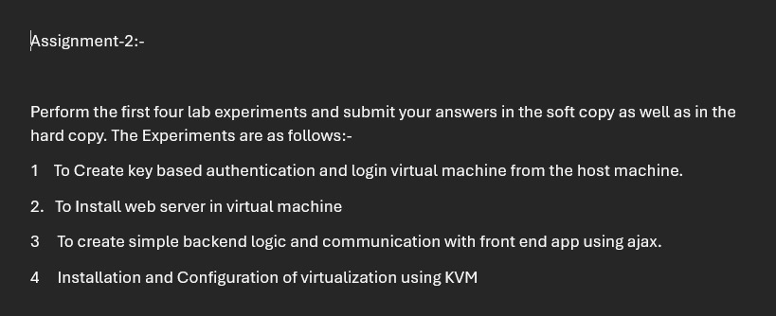

**Experiment - 1**

**Aim : To create a key based authentication and login virtual machine from the host machine**

1. SetUp a virtual machine
2. Enable Windows Subsystem for Linux (WSL):
   1. dism.exe /online /enable-feature /featurename:Microsoft-Windows- Subsystem-Linux /all /norestart

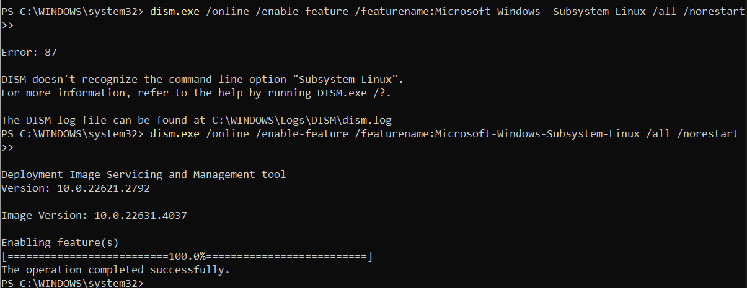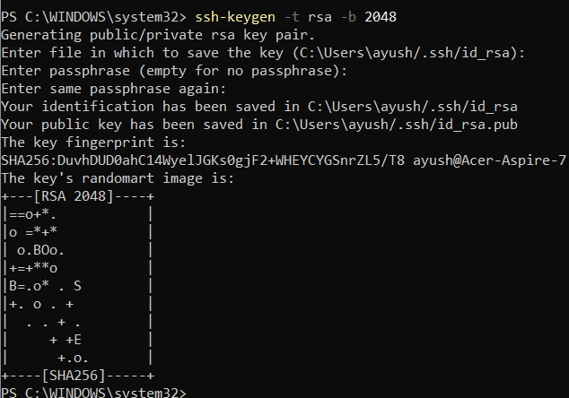

1. On windows create a key file using the command “ssh-keygen”
2. Install Open SSH server on virtual machine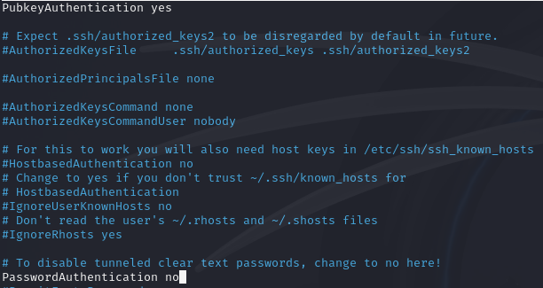

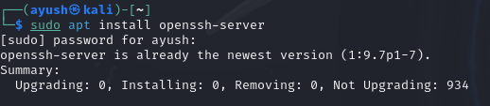

1. Configure SSH and turn ON these :
   1. PubKeyAuthentication yes
   2. PasswordAuthentication no
2. Now restart SSH using the command:
   1. sudo systemctl restart ssh
   2. 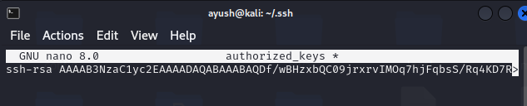
3. Create a file authorized_keys in the .ssh directory and paste the window’s public key in it
   1. cat ~/.ssh/id_rsa.pub | clip
4. Set the correct permissions for the .ssh directory and the authorized_keys file:
   1. chmod 700~/.ssh
   2. chmod 600 ~/.ssh/authorized_keys
5. SSH into the vm using the command , using vm name and ip address
   1. ssh -i ~/.ssh/id_rsa ayush@10.0.3.15



**Experiment - 2**

**Aim : To install Web Server in Virtual Machine**

Pre-Requisite : Install a virtual machine and setup Linux OS

1. Update the System : sudo apt update/upgrade 2. Install Apache Web Server : sudo apt install apache2

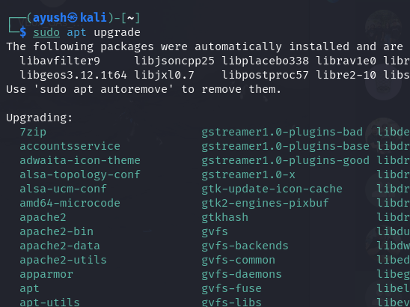 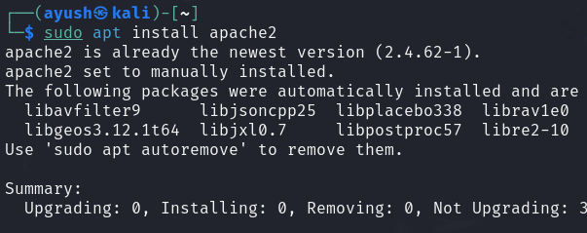

3. Start the Apache server : 4. Enable Apache Server :

sudo systemctl start apache2 sudo systemctl enable apache2 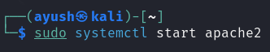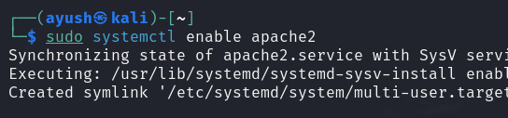

5. Verify Server is installed or not : sudo systemctl status apache2

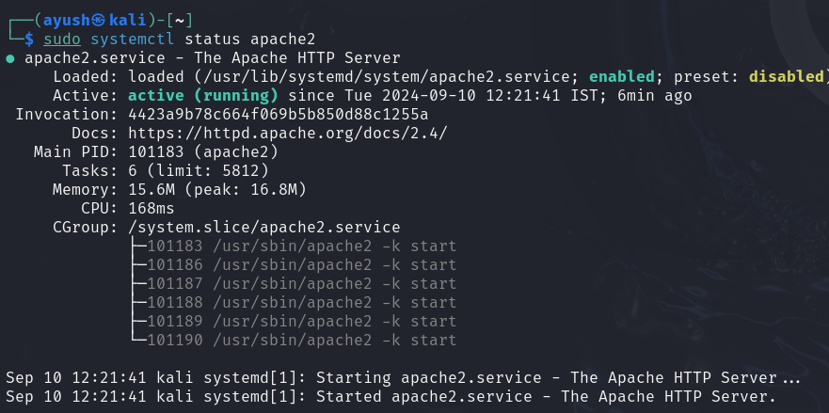

**Experiment - 3**

**Aim : To create simple back-end Logic and communication with front-end app using AJAX**

1. **AJAX :** Asynchronous JavaScript and XML) is a set of web development techniques used to create dynamic and interactive web applications. It allows web pages to be updated asynchronously by exchanging small amounts of data with the server.
2. We used Node.js and Express to create a Backend Server, HTML for Frontend
3. The function fetch() in the code uses AJAX to make a request to the server.
4. Backend and Front end code 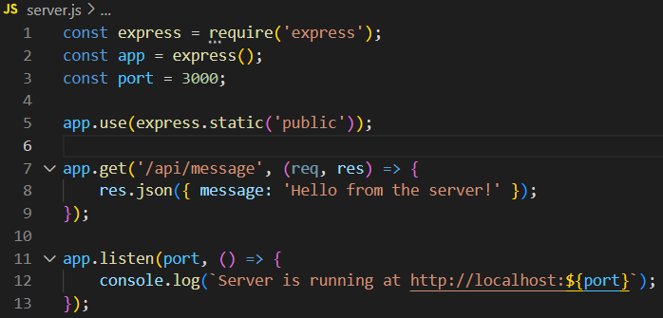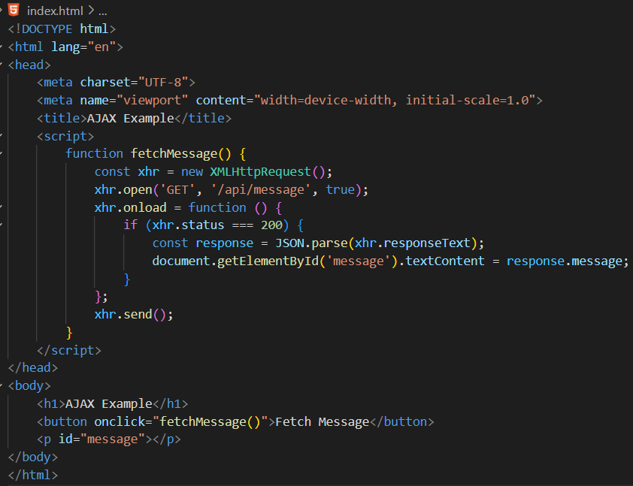

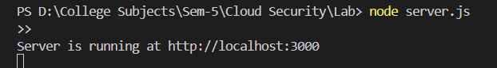

1. Start the server, and test the AJAX, fetch() method

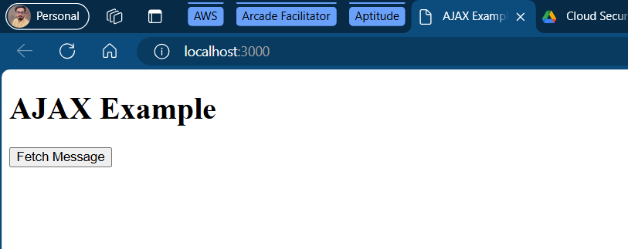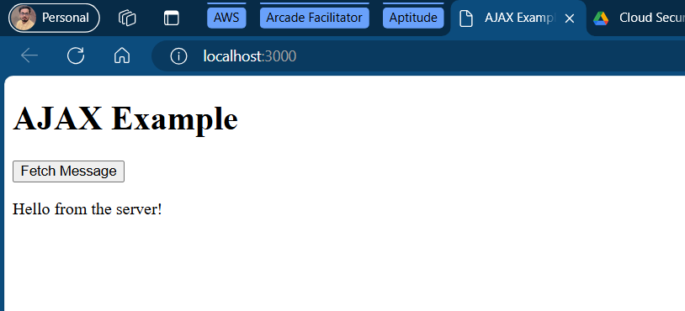

**Experiment - 4**

**Aim : Installation & Configuration of Virtualisation using KVM**

1. SetUp a virtual machine with Linux OS, since KVM is only available in Linux
2. Enable Nested Virtualisation from Virtual Box.
3. Update the Virtual OS :
   * sudo apt update

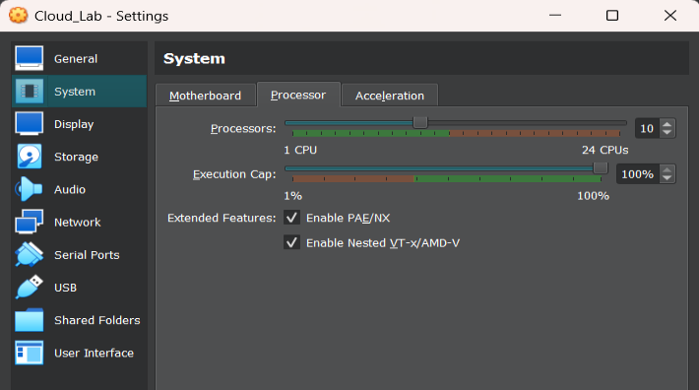

1. Install Qemu and Qemu KVM:
   * sudo apt install qemu
   * sudo apt install qemu-kvm
2. Install other support files, virtualisation managers, daemon setups
   * sudo apt install virtinst
   * sudo apt install libvirt-daemon-system
   * sudo apt install virt-manager
   * sudo apt install bridge-utils
   * sudo systemctl is-active libvirtd
   * sudo systemctl enable --now libvirtd

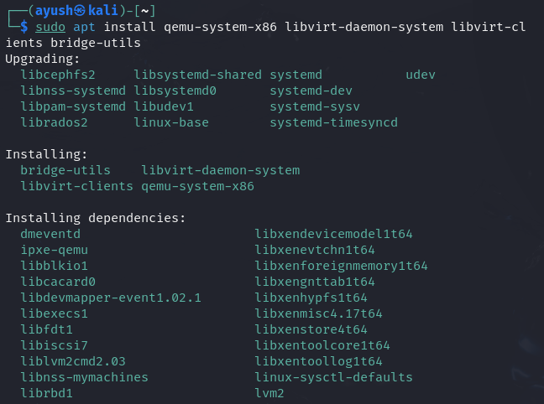 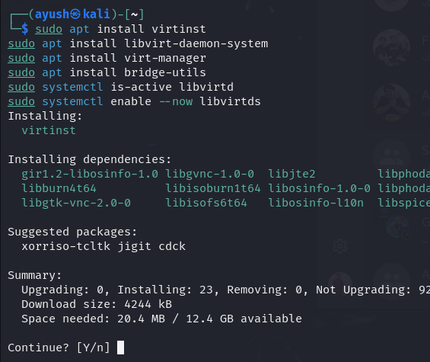

1. Add current user to groups to be able to manage KVM machines
   * sudo usermod -aG libvirt $USER
   * sudo usermod -aG kvm $USER

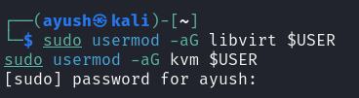

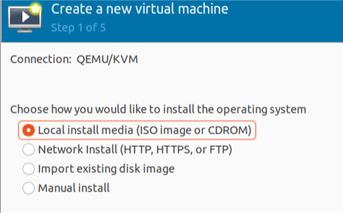

1. Install ISO image and run the Virtual Machine on Qemu - KVM

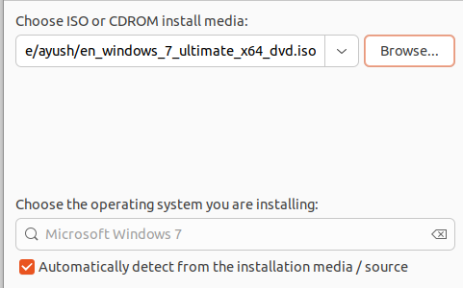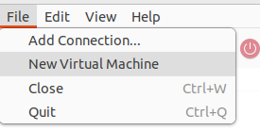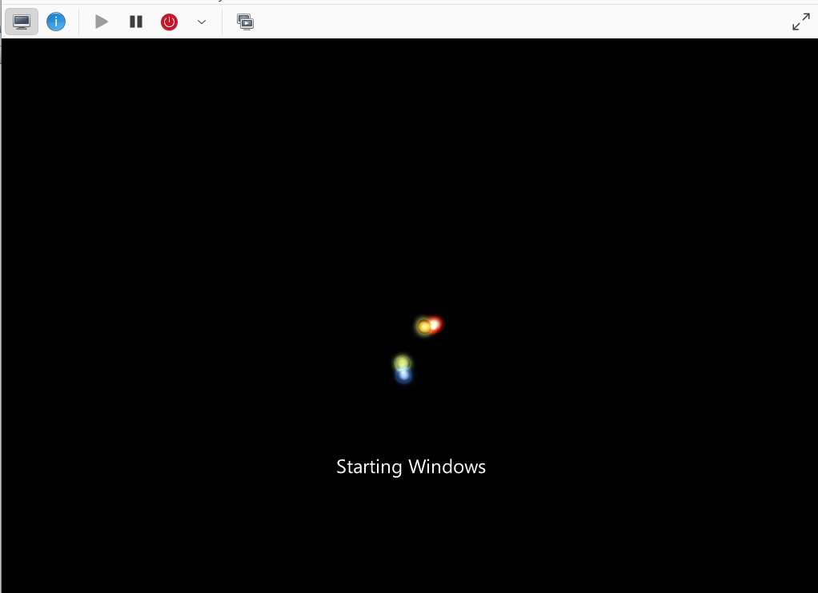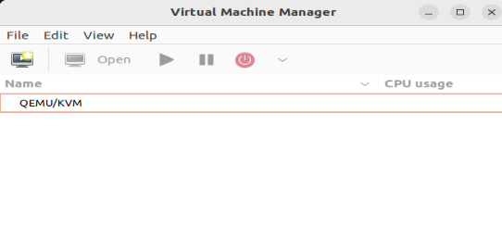

Successful Virtualization Windows 7 Guest Virtual Machine using KVM on a Linux Host System.